

Assignment 3B: Project Process Book
COS30045 – Data Visualisation
Teaching Period 02, 2026

Project Topic: OECD Health Statistics

Healthcare Spending and Life Expectancy Across OECD Countries

Team Members – 1E
Syed Muhammad Mahdi | 105172195
Dilhani Seneviratne | 101133033

Mercury Website: Does increased health-care spending increase life expectancy?
GitHub Link: SyedMahdi15/COS30045-Data-Visualisation-Project
Total Word Count: 2,508

Table of Contents
1. Introduction 3
1.1 Background and Motivation 3
1.2 Visualisation Purpose 3
1.3 Project Schedule 4
1.4 Team Collaboration and Project Setup 5
2. Data 7
2.1 Data Sources 7
2.2 Data Processing 7
3. Requirements 9
3.1 Must-have Features 9
3.2 Optional Features 9
4. Visualisation Design 11
5. Validation 13
5.1 Informed Consent 13
5.2 Participant Profile 13
5.3 Evaluation and Satisfaction Survey 13
5.4 Usability Findings & Qualitative Feedback 14
Positive Feedback 14
Pain Points 14
5.5 Design Improvements 14
6. Conclusion 15
7. References 16
Appendix 17
Appendix A: Team Collaboration setup 17
Appendix C: Visualisation Iteration Example 18
Appendix C: Participant Ethics & Consent Form 19

1. Introduction

1.1 Background and Motivation
The primary objective of this project is to explore the link between healthcare expenditure and life expectancy at the national level by investigating the spending patterns and life expectancy across ten selected OECD countries over a ten-year period (2015 to 2024, inclusive). The analysis of health expenditures is central to the formation of public health policy, with spending and life expectancy serving as two important benchmarks of a countries healthcare efficiency and population health.
However, country’s allocate varying levels of resources toward healthcare and have varying life expectancy outcomes as a result. Anwar et al. (2023) highlight that healthcare investment brings both short-term and long-term economic benefits and is a prerequisite for long-term sustainable development by increasing the value of human life leading to higher productivity and economic performance. However, government spending is only part of the story; economic and environmental factors must also be considered, as the degradation of the environment increases the prevalence of illness, thereby increasing health spending.
This study examines ten OECD nations: Australia, Canada, France, Germany, Italy, Japan, Korea, New Zealand, United Kingdom and the United States.
The resulting interactive visualisations are designed for students, researchers, policymakers and the general public. By presenting statistical trends visually rather than through tabular data, users will be able to compare countries, look at changes over time and find relationships between the cost of health care and the length of life. Crucially, the visualisations demonstrate that higher healthcare spending does not automatically guarantee proportional gains in life expectancy – for example, the United States has the highest expenditure but lowest life expectancy in the sample. In contrast, several East Asian and European countries have low health expenditure but high life expectancy signalling highly efficient systems alongside other social factors.

1.2 Visualisation Purpose
This project examines the link between healthcare expenditure and life expectancy. The core analysis is framed around five guiding research questions:
- Do countries that spend more on healthcare tend to have longer life expectancy?
- How does healthcare spending per person differ across the selected OECD countries?
- What is the life expectancy in each of the selected OECD countries?
- How have healthcare expenditure and life expectancy changed between 2015 and 2024?
- Which countries have a relatively long life expectancy compared to their healthcare spending?
The finished visualisation will enable users to explore these relationships interactively and then compare between countries and years.

1.3 Project Schedule
To effectively monitor and manage progress throughout the Teaching Period, the project has been divided into six key phases:
- Project Initiation & Planning
- Project Setup & Data Collection
- Data Preparation & Design
- Development & Implementation
- Testing, Evaluation & Reflection
- Finalisation & Submission

Period | Planned Work | Assessment Due
Weeks 4 + 5 | Project Initiation & Planning  - Establish team communication and collaboration channels.  - Review project requirements.  - Discuss project topics.
Week 6 | - Select OECD Health Statistics topic + visualisation purpose questions.  - Identify datasets to be utilised for the visualisations.
Week 7 | Project Setup & Data Collection  - Create GitHub repository.  - Collect datasets.  - Begin initial website development (excluding visualisations).
Week 8 | Data Preparation & Design  - Complete standup 1 report.  - Document the project details for the project process book. | Assignment 3A: Project Standup 1
Week 9 | - Clean and process datasets.  - Finalise website design.  - Develop initial visualisation concepts.
Week 10 | Development & Implementation  - Develop D3 visualisations and interactive features.  - Complete standup 2 report. | Assignment 3A: Project Standup 2
Week 11 | - Refine data visualisations, website design and user interactions.  - Complete standup 3 report. | Assignment 3A: Project Standup 3
Week 12 | Testing, Evaluation & Reflection  - Test the website and visualisations.  - Implement improvements based on testing  - Complete standup 4 report.  - Commence project reflection and peer review. | Assignment 3A: Project Standup 4
Exam Period | Finalisation & Submission  - Finalise the Project Process Book for submission.  - Finalise the Website and Visualisation for submission.  - Complete project reflection and peer review. | Assignment 3B: Project process book  Assignment 3C: Website and visualisation  Assignment 3D: Project reflection and peer review

1.4 Team Collaboration and Project Setup
As Team 1E, we established communication via Canvas messages and decided to continue collaboration via Microsoft Teams. We quickly established that team members had opposite personal schedules, therefore making it difficult to settle on a consistent meeting time. Text communication has been the default method with space for ad-hoc meetings via call as required. The team agreed to consolidate project version control and document management to a shared GitHub repository for ease of use.
Communication method: Microsoft Teams
Document management + Version Control: GitHub (linked on the title page)

2. Data

2.1 Data Sources
Two core datasets from the OECD Health Statistics were selected:
- Life Expectancy at Birth: Annual observations measured in years (Total population, 0 years at birth).
- Healthcare Expenditure: Total annual expenditure per capita measured in current US dollars using Purchasing Power Parity (USD PPP).
Both datasets were processed in CSV format, stored into to the project's shared GitHub repository, and loaded dynamically using D3.js.

Data source:
- OECD Health Statistics – Life Expectancy
- OECD Health Statistics – Health Expenditure and Financing
The datasets are mostly tabular data including categorical and quantitative data.

2.2 Data Processing
The OECD data sets include observations for a number of countries, years and health related measures. To prevent visual clutter while preserving analytical depth, the dataset was constrained to 10 representative OECD nations across 10 calendar years (2015–2024), resulting in a standardized dataset of 100 consolidated observations (10 countries x 10 years).
Data Type | Attribute Name | Description
Categorical | Country | Selected OECD nation name.
Temporal | Calendar year | Calendar observation year (2015–2024).
Quantitative | Life expectancy | Life expectancy at birth in years (Total population).
Quantitative | Health Expenditure | Total per capita health spending in USD (PPP).

The data set that is merged at the end is of 100 observations (10 years x 10 countries).
In JavaScript, the data was merged and filtered, for the visualisations to be based on consistent country and year information without including unneeded fields from the underlying OECD data.
Data loading and transformation were executed client-side via D3.js using Promise.all():
Filtering: The annual data from 2015 to 2024 for the specified countries was narrowed to total population at birth for life expectancy and to total per-capita spending in current PPP-converted US dollars for health expenditures.
Cleaning: The string fields (TIME_PERIOD and OBS_VALUE) were converted into the numeric types (year, lifeExpectancy, and healthSpending).
Joining: A left join was performed on the life expectancy dataset, matching health expenditure data by country and year while returning null for missing spending records.
Colour mapping: The standardized Tableau10 palette was applied across all charts to ensure consistent visual identity per country.

3. Requirements

3.1 Must-have Features
The following requirements were identified during the planning stage. All must-have features were implemented in the final website
Requirement | Implementation Status
Import OECD health statistics into D3.js | Completed – Both CSV datasets are loaded and processed using D3.js.
Visualise healthcare expenditure and life expectancy | Completed – A scatter plot and two line charts were developed.
Compare the selected OECD countries | Completed – The visualisations display data for ten selected countries.
Show changes over time | Completed – The line charts show annual data from 2015 to 2024.
Clearly label axes, values and countries | Completed – The charts include axes, labels, legends and interactive tooltips.
Provide suitable titles and descriptions | Completed – Each visualisation has a title and an explanation of its purpose.
Make the visualisations available online | Completed – The website is hosted on the Mercury server.
Make the visualisations understandable and easy to use | Implemented – The website includes five guiding questions, a consistent layout and interactive chart features. User testing will provide further feedback on usability.

3.2 Optional Features
Several optional features were considered to improve user interaction and accessibility. The final implementation includes interactive tooltips, country highlighting, trend charts, and a responsive layout.
Optional Feature | Implementation Status
Display detailed values in tooltips | Completed – Hovering over chart data displays country-specific information.
Country selection or filtering | Completed – Users can highlight individual country trends by selecting the country name from Legend or within Visual 1, which isolates it in all visualisations.
Country deselection | Not implemented – Unable to unselect a country by selecting elsewhere on the website.
Year selection or filtering | Not implemented – The line charts display the full 2015–2024 period, while the scatter plot uses the latest available observation for each country.
Highlight individual countries | Completed – Hovering over a country highlights its line and fades the other lines.
Animated transitions when filters change | Implemented – When a country is selected the animation plays.
Include additional charts showing trends over time | Completed – Separate line charts show healthcare spending and life expectancy trends.
Support different screen sizes | Completed – The layout adapts to smaller screens, with horizontal scrolling for charts on mobile devices.

The optional features were prioritised according to their usefulness, user testing feedback and available development time. Interactive tooltips and country highlighting were implemented to support comparison without adding complex filtering controls. The country filtering was added after user testing.

4. Visualisation Design
During the early design stage, several visualisation approaches were considered. Before selecting the final design.

Design Idea 1 – Bar Chart
A bar chart was considered to be used to demonstrate the spending of each country how they visually stack against each other. This was rejected due to the cluttered look. A line chart was favoured due to its ability to display the two variables together.

Design Idea 2 – Dumbbell
A dumbbell chart was considered as a simple way to show the data as progression of time, however was rejected for a consistent chart standard.

Design Idea 3 – Scatter Plot
A scatter plot could display healthcare expenditure on the x-axis and life expectancy on the y-axis with each point representing a country. This would make it easier to compare whether countries with higher healthcare expenditure also tend to have higher life expectancy.

Design Idea 4 – Line Chart
A line chart could show changes in healthcare expenditure or life expectancy over time. Users could select or compare countries to observe long-term trends, with a clean visual standard.

Design Idea 5 – Combined Interactive Dashboard
A dashboard could combine the scatter plot and line chart with filters for country and year. Selecting a country or year could update the visualisations and allow users to explore the data interactively.

The team selected scatterplots and line graphs, as the variables being presented (time & numerical) are best suited for these. The visualisations were further refined with user testing. See Appendix B for an example, where a design was improved after the feedback was implemented.

User Question | Visualisation | Insight Provided
Q1: Do higher spending countries have longer life expectancy? | Visual 1: Scatter Plot | Displays correlation and returns of spending over time.
Q2: How does spending per person differ across countries? | Visual 2: Expenditure Line Chart | Highlights USD PPP spending disparities over time.
Q3: What is life expectancy across OECD nations? | Visual 3: Life Expectancy Line Chart | Displays relative health outcomes over time.
Q4: How have spending and longevity changed from 2015 to 2024? | Visuals 2 & 3 | Illustrates temporal trajectories and COVID-19 pandemic impacts.
Q5: Which countries achieve high life expectancy relative to spending? | Visual 1 | Identifies high-efficiency nations.

5. Validation

5.1 Informed Consent
To adhere to academic research standards and guidelines, all user testing participants were provided with an informed Consent Form prior to testing – see Appendix C: Participant Ethics & Consent Form.
- Participants were informed that participation was voluntary and could withdraw at any point.
- No personal identifiers are included in the reporting, and codes were assigned to protect privacy.

5.2 Participant Profile
The user testing was conducted with 2 participants across different levels of technical familiarity.
Participant Code | Age Range | Occupation/Background | Data Visualisation Experience | Device
P1 | 35 - 40 | Interior Designer | Novice | Desktop
P2 | 30 - 35 | IT Professional | Advanced | Laptop

5.3 Evaluation and Satisfaction Survey
Testing was conducted live, in-person, with observational walkthroughs. Participants were given zero instruction on how to interact with the visualisations to observe the user-interface intuitiveness. They were asked to verbally contextualise their attempts at 4 tasks:
- Task 1 (Data Retrieval): "Identify which country had the highest healthcare expenditure per person in 2024."
- Task 2 (Trend Analysis): "Find the period where life expectancy decreased significantly across multiple countries and explain what caused it."
- Task 3 (Comparative Outcome): "Identify a country that achieves a relatively high life expectancy despite having a lower healthcare budget than the US."
- Task 4 (Interaction & Navigation): "Filter or highlight 'Australia' across all visualisations on the page."

Following the task completion, the participants completed a post-test questionnaire using a 5-point scale.
Evaluation Metric | Question Statement | P1 Score | P2 Score
Ease of Use | "The dashboard was easy and intuitive to navigate." | 5 | 5
Visual Clarity | "The charts and colour choices made it easy to distinguish countries." | 5 | 4
Data Usefulness | "The interactive features helped me answer the research questions effectively." | 3 | 2.5
Overall Satisfaction | "I enjoyed exploring the website and discovering health trends." | 4 | 3

5.4 Usability Findings & Qualitative Feedback

Positive Feedback
- The website layout is intuitive, and the text to visualisation ratio is good for readability.
- The conclusion, or key points are short and simple.
- The website is simple and easy to navigate.

Pain Points
- The legends for Visuals 2 and 3 were unclear because the legend entries appeared to line up with the lines directly beside them.
- It is hard to isolate information about a country, need to hover the graph and have forgotten the information when looking at the different visuals.
- Hard to see information when the lines crossed for visual 3.

5.5 Design Improvements
Based on usability testing and feedback, several design improvements were identified to enhance readability, user engagement, and data interpretation:
Identified Usability Issue | Action
Unclear legends & visual overlap.  Line entries were hard to trace in Visuals 2 & 3. | Implemented subtle gridlines in Visual 1 and enabled global country filtering via legend/node selection.
Users forgot data when scrolling between visuals. | Implemented country filtering, where selecting a country highlights its trajectory and updates summary stats globally across all views.
Hard to follow the overall story/answers to the guiding questions. | Added brief contextual summaries answering each guiding question behind each question card.
Visual 1 lacked explicit colour coordination with the other visuals. | Applied the Tableau10 colour scale uniformly across all visual elements (Visual 1, 2, and 3).

6. Conclusion
This project demonstrates that higher healthcare expenditure does not guarantee superior life expectancy outcomes. While nations like the United States spend significantly more per capita for lower life expectancy, some East Asian and European countries achieve superior health outcomes with considerably lower financial allocations. Across the 2015–2024 decade, healthcare spending broadly increased, while life expectancy experienced a temporary drop surrounding the COVID-19 pandemic.
Limitations encountered during this project included tight development timelines that restricted minor UI enhancements that could have enhanced the user experience.
Future iterations of this platform could incorporate, options such as the ability to filter by year, timeline sliders, and expansion to all 38 OECD member nations for a comprehensive overview.

7. References
Anwar, A., Hyder, S., Nor, N. M., & Younis, M. (2023). Government health expenditures and health outcome nexus: A study on OECD countries. Frontiers in Public Health, 11, Article 1123759. https://doi.org/10.3389/fpubh.2023.1123759
Organisation for Economic Co-operation and Development. (n.d.). Health expenditure and financing [Data set]. OECD Data Explorer. https://data-explorer.oecd.org/vis?df[ds]=dsDisseminateFinalDMZ&df[id]=DSD_SHA%40DF_SHA&df[ag]=OECD.ELS.HD&df[vs]=1.1&dq=.A.EXP_HEALTH.PT_B1GQ._T.._T.._T...&pd=2015,&to[TIME_PERIOD]=false
Organisation for Economic Co-operation and Development. (n.d.). Life expectancy [Data set]. OECD Data Explorer. https://data-explorer.oecd.org/vis?df[ds]=dsDisseminateFinalDMZ&df[id]=DSD_HEALTH_STAT%40DF_LE&df[ag]=OECD.ELS.HD&df[vs]=1.1&dq=.A...Y0........&pd=2015,&to[TIME_PERIOD]=false

Appendix

Appendix A: Team Collaboration setup
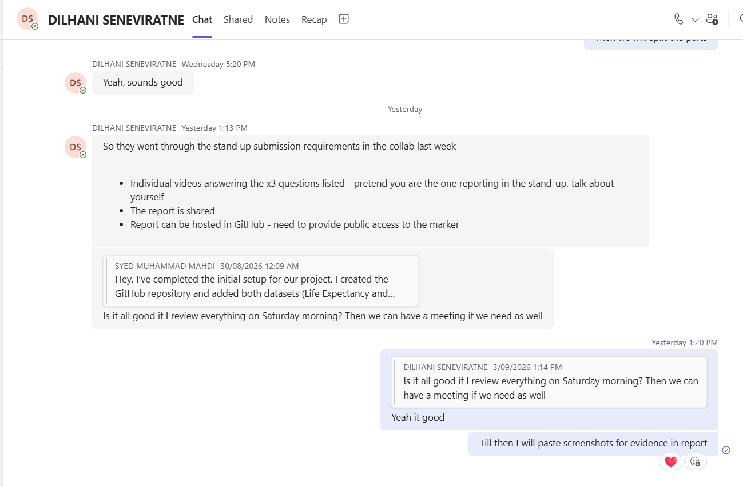
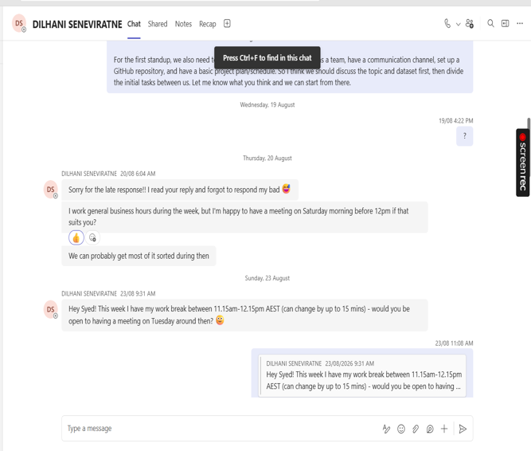
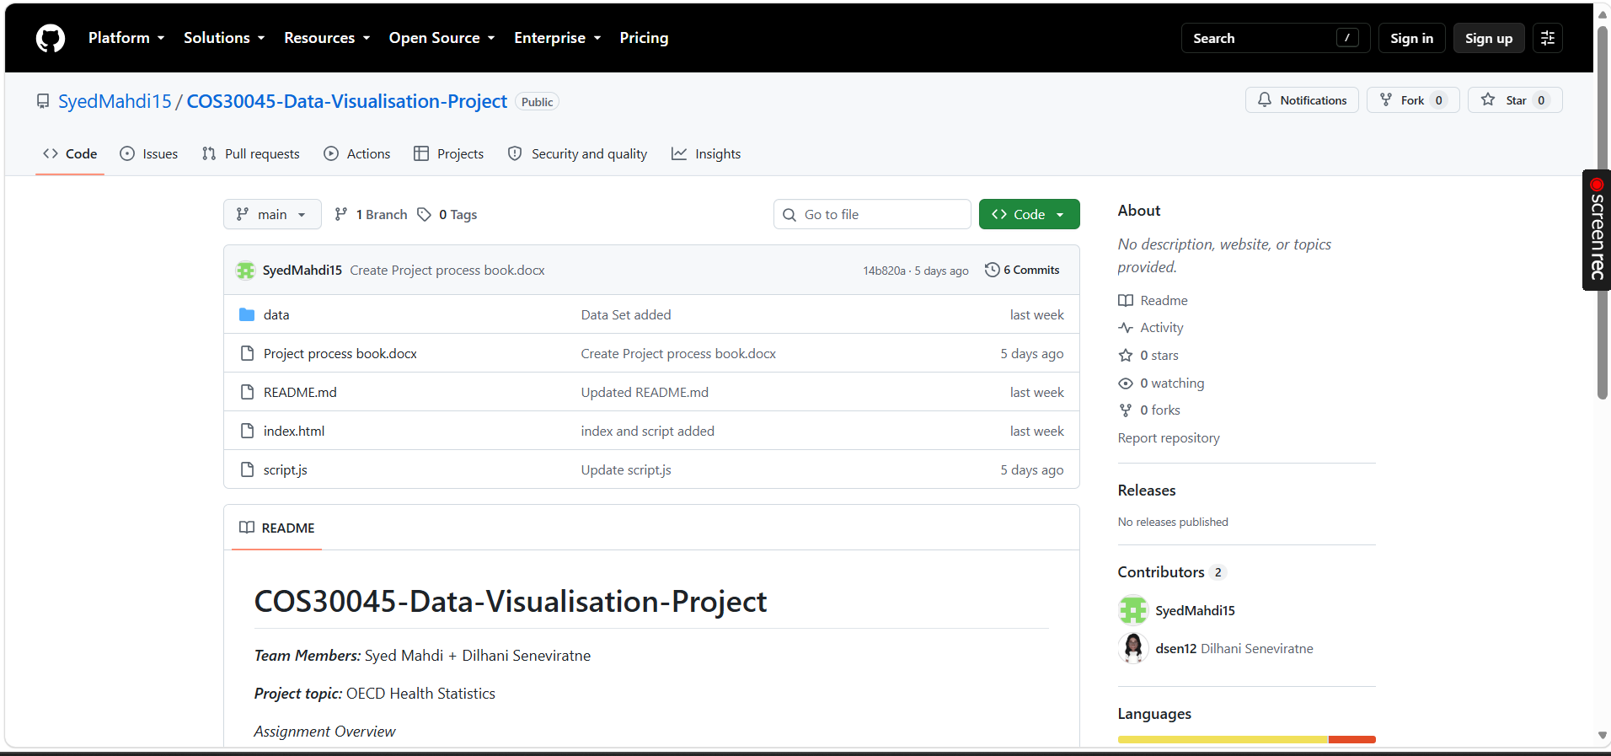

Appendix C: Visualisation Iteration Example
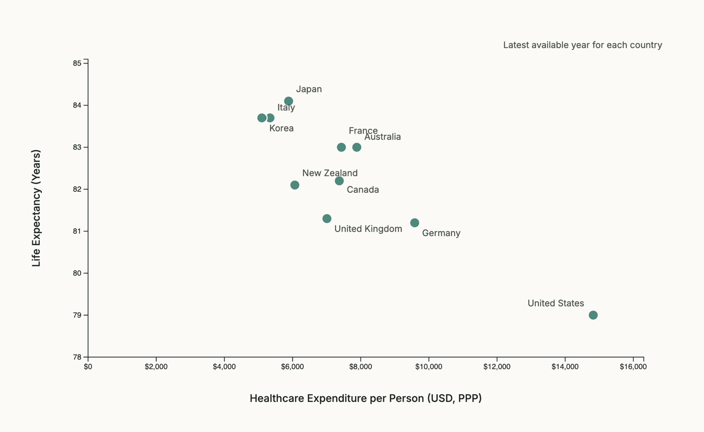
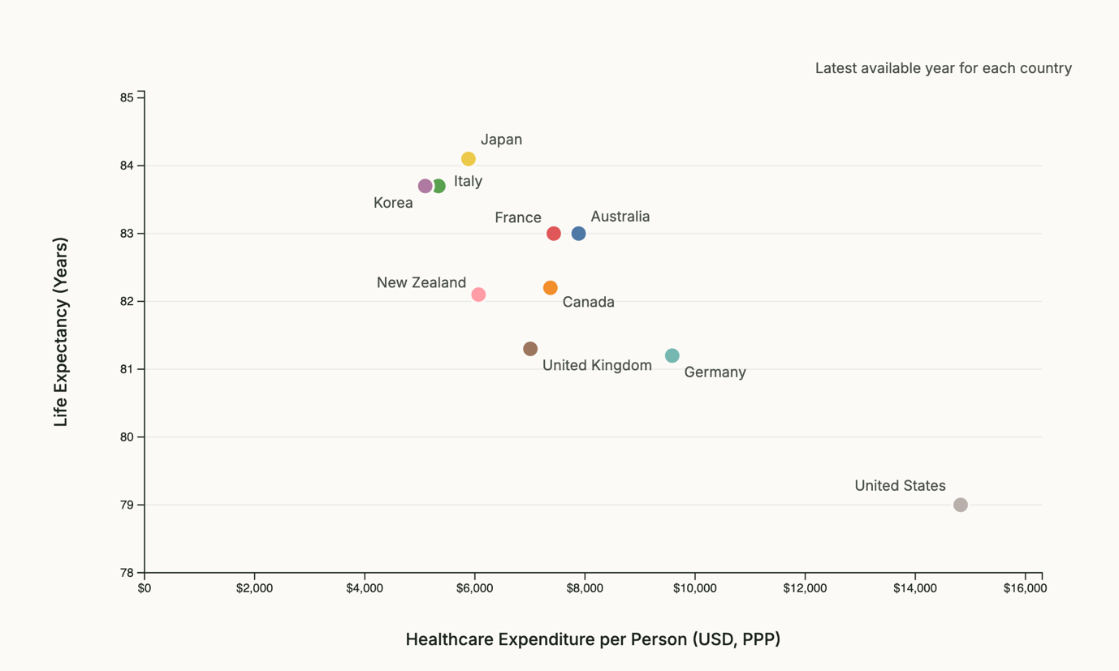

Appendix C: Participant Ethics & Consent Form
Project Title: OECD Healthcare Expenditure & Life Expectancy Visualisation Dashboard
Course: COS30045 Data Visualisation (Assignment 3)
1. Purpose of Study: You are invited to participate in a usability evaluation of an interactive data visualisation website exploring healthcare spending and life expectancy across OECD nations.
2. Participant Involvement: You will be asked to perform 4 brief data discovery tasks using the website and complete a short 4-question feedback survey. This session takes approximately 10–15 minutes.
3. Confidentiality: All collected data is completely anonymous. No personal identifiers, name, or contact details will be stored or published in the final academic report.
4. Voluntary Participation: Your participation is completely voluntary. You may choose to stop at any time without providing a reason.

Participant Declaration:
I have read and understood the information above and voluntarily agree to participate in this evaluation study.
Participant Code:
Date:
Initials (digital signature):

